
Object Oriented Programming Lab Manual

Lab 04

Objectives:
Introduction to Inheritance

Student Information

Student Name
Student ID
Date
Assessment
Marks Obtained
Remarks
Signature

Lab-04
Inheritance

Objective:
To familiarize students with the concept of Inheritance and its advantages. Coding examples related to inheritance.
Use of super keyword
Example of child class referring Parent class method using super Keyword;

Apparatus:
Hardware requirements:
Dual core CPU based on x64 architecture Minimum of 1 GB RAM
800 MB of disk space Software requirements: Windows 7 SP1 (64 bit)
Java JDK 8 (64 bit JVM)
NetBeans IDE (version 8.1 or above)

Background:
Inheritance and its advantages.

The capability of a class to derive properties and characteristics from another class is called Inheritance. Inheritance is one of the most important feature of Object Oriented Programming.
Sub Class:
The class that inherits properties from another class is called Sub class or Derived Class.
Super Class:
The class whose properties are inherited by sub class is called Base Class or Super class.

Consider a group of vehicles. You need to create classes for Bus, Car and Truck.
The methods fuelAmount(), capacity(), applyBrakes() will be same for all of the three classes.
If we create these classes avoiding inheritance then we have to write all of these functions in each of the three classes as shown in below figure:
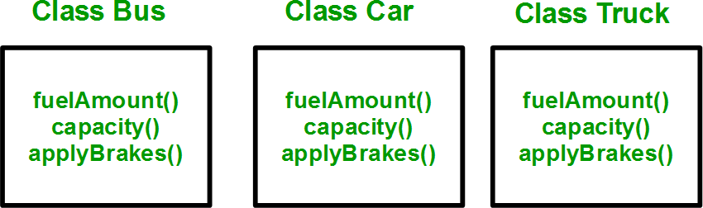

This increases the chances of error and data redundancy. To avoid this type of situation, inheritance is used. If we create a class Vehicle and write these three functions in it and inherit the rest of the classes from the vehicle class, then we can simply avoid the duplication of data and increase re-usability. Look at the below diagram in which the threeclasses are inherited from vehicle class

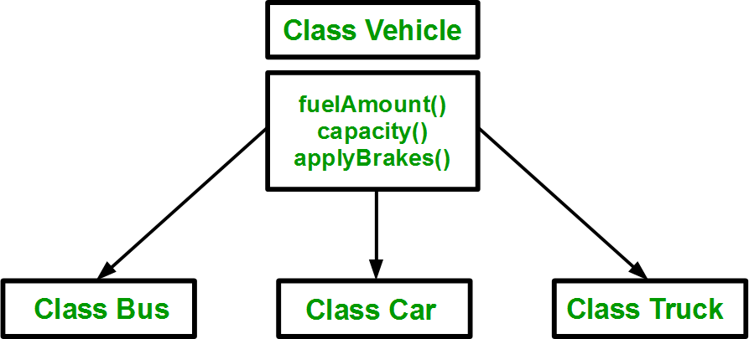

Inheritance in object-oriented programming provides a powerful mechanism for building complex and extensible systems while promoting code reusability, modularity, and organization. It enables you to model relationships between classes and create specialized objects while maintaining a clear and efficient codebase.
Syntax:
class subclass_name : access_mode base_class_name
{
//body of subclass
};

Code:
// Java Program to illustrate Inheritance (concise) import java.io.*;
// Base or Super Class class Employee {
int salary = 60000;
}

// Inherited or Sub Class
class Engineer extends Employee { int benefits = 10000;
}

// Driver Class

class Gfg {
public static void main(String args[])
{
Engineer E1 = new Engineer(); System.out.println("Salary : " + E1.salary
+ "\nBenefits : " + E1.benefits);
}
}
Now in this example, we have a base class Animal with a speak method, and two subclasses Dog and Cat that inherit from Animal and override the speak method with their own implementations.
Code:
class Animal { void speak() {
System.out.println("The animal speaks.");
}
}

class Dog extends Animal { void speak() {
System.out.println("The dog barks.");
}
}

class Cat extends Animal { void speak() {
System.out.println("The cat meows.");
}
}

public class InheritanceExample {
public static void main(String[] args) { Animal animal = new Animal(); Dog dog = new Dog();
Cat cat = new Cat();

animal.speak(); // Output: The animal speaks. dog.speak(); // Output: The dog barks. cat.speak(); // Output: The cat meows.
}
}
Use of super keyword

In Java, the super keyword is used to refer to the superclass or parent class. It has several important uses and applications:
Call Superclass Constructor: One common use of super is to call the constructor of the superclass when you're creating an instance of a subclass. This is often done in the constructor of the subclass to initialize the inherited attributes. For example:

class Animal { String name;
Animal(String name) { this.name = name;
}
}

class Dog extends Animal { String breed;

Dog(String name, String breed) { super(name);
this.breed = breed;
System.out.println("Name: " + name + ", Breed: " + breed);
}
}

public class InheritanceExample {
public static void main(String[] args) {
Dog myDog = new Dog("Buddy", "Golden Retriever");
}
}

Code:
// Parent class (also known as the superclass) class Vehicle {
String brand; int year;

Vehicle(String brand, int year) { this.brand = brand;
this.year = year;
}

void start() {
System.out.println("Starting the vehicle");
}

void stop() {
System.out.println("Stopping the vehicle");
}
}

// Child class (also known as the subclass) that inherits from the Vehicle class class Car extends Vehicle {
int numberOfDoors;

Car(String brand, int year, int numberOfDoors) { super(brand, year); // Call the constructor of the superclass this.numberOfDoors = numberOfDoors;
}

void accelerate() {
System.out.println("Car is accelerating");
}
}

public class Main {
public static void main(String[] args) {
// Create an instance of the Car class
Car myCar = new Car("Toyota", 2022, 4);

// Access fields and methods from both the parent and child classes System.out.println("Car brand: " + myCar.brand); System.out.println("Car year: " + myCar.year); System.out.println("Number of doors: " + myCar.numberOfDoors);

myCar.start(); myCar.accelerate(); myCar.stop();
}
}

Access Superclass Methods: You can use super to call methods from the superclass if the subclass overrides them. This is useful when you want to access the overridden method from the subclass. For example:

class Animal { void speak() {
System.out.println("The animal speaks.");
}
}

class Dog extends Animal { void speak() {
super.speak(); // Calls the superclass method System.out.println("The dog barks.");
}
}
public class InheritanceExample {
public static void main(String[] args) { Dog myDog = new Dog(); myDog.speak();
}
}

Code
class Animal {
void makeSound() {
System.out.println("The animal makes a sound.");
}
}

class Dog extends Animal { void makeSound() {
super.makeSound(); // Calls the makeSound method of the superclass (Animal) System.out.println("The dog barks.");
}

void performTrick() {
System.out.println("The dog performs a trick.");
}
}

public class Main {
public static void main(String[] args) { Dog myDog = new Dog();

myDog.makeSound(); // Calls the makeSound method in the Dog class myDog.performTrick(); // Calls the performTrick method in the Dog class
}
}

The super keyword is a crucial tool for managing the relationship between classes in inheritance hierarchies, enabling proper initialization, access, and method invocation.

Modes of Inheritance Public mode:
If we derive a sub class from a public base class. Then the public member of the base class will become public in the derived class and protected members of the base class will become protected in derived class.
Protected mode: If we derive a sub class from a Protected base class. Then both public member and protected members of the base class will become protected in derived class.
Private mode: If we derive a sub class from a Private base class. Then both public member and protected members of the base class will become Private in derived class.
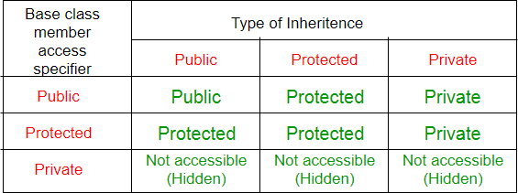

Lab exercises:
Lab#4: The fundamentals concept of Inheritance.
Objective: This experiment introduces the students about the fundamentals concept of Inheritance.

Task 1: Creating a Parent Class (Super Class)
- Create a class named Animal with the following instance variables:
  - name
  - age
- Create a method named makeSound() that prints "Generic animal sound".
Task 2: Creating a Child Class (Sub Class)
- Create a class named Dog that extends the Animal class.
- Override the makeSound() method in the Dog class to print "Woof!".
Task 3: Creating Another Child Class
- Create a class named Cat that extends the Animal class.
- Override the makeSound() method in the Cat class to print "Meow!".
Task 4: Creating Objects and Calling Methods
- Create objects of the Dog and Cat classes.
- Call the makeSound() method on each object to demonstrate polymorphism.
Task 5: Understanding Inheritance Hierarchy
- Create a class named GoldenRetriever that extends the Dog class.
- Explain how inheritance creates a hierarchical relationship between classes.
- Discuss the concept of single inheritance and multiple inheritance (which is not directly supported in Java).

